Ex: 05 WEB SERVER & XML DATA PARSING USING NODE JS Date: 12.1.2026
Name: Ajay Kumar S
Roll no: 2024503701
Aim:
To design web server and xml data creation and parsing it using Node Js.
Description:
The web server is developed using Node.js to handle client requests and responses efficiently. XML is used for data storage and exchange, where data is dynamically created and parsed on the server side. Node.js processes the XML data, extracts required information, and sends structured responses to the client, enabling smooth and organized communication between the server and applications.
Node JS Concepts Used:
- Node.js runtime environment – Used to execute JavaScript on the server side
- HTTP module – Used to create and run a web server
- Web server creation – Using http.createServer() to handle client requests and responses
- HTTP response handling – Setting headers and sending responses using writeHead() and end()
- Port listening – Running the server on a specified port using server.listen()
- File System (fs) module – Used to read external files from the system
- XML data handling – Reading and processing XML files
- xml2js library – Used to parse XML data into JavaScript objects
- XML parsing – Converting XML content into usable JavaScript data structures
- Asynchronous programming – Using callbacks for file reading and XML parsing
- Error handling – Managing errors during file reading and XML parsing
Code:

Server.js:
const http = require("http");
const server = http.createServer((req, res) => {
res.writeHead(200, { "Content-Type": "text/plain" });
res.end("Hello World! Welcome to Node.js Web Server By Ajay Kumar [2024503701]");
});
server.listen(3000, () => {
console.log("Server running at http://localhost:3000");
});

Parse.js:
const fs = require("fs");
const xml2js = require("xml2js");
const parser = new xml2js.Parser();
fs.readFile("students.xml", (err, data) => {
if (err) throw err;

parser.parseString(data, (err, result) => {
if (err) throw err;
console.log(result.students.student);
});
});
student.xml:
<students>
<student>
<id>101</id>
<name>Ajay</name>
<course>Computer Science</course>
</student>
<student>
<id>102</id>
<name>Rahul</name>
<course>Information Technology</course>
</student>
</students>
Output:

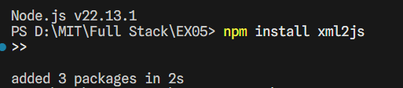
Figure(a) Installation of xml2js package

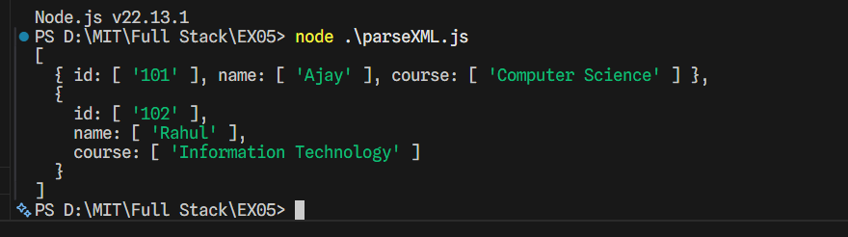
Figure(b)Console Output

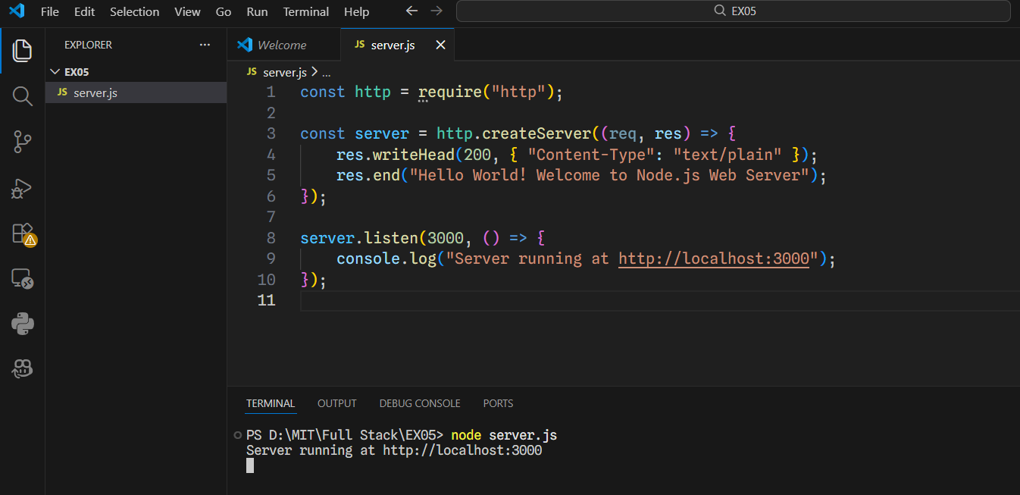
Figure(c)Server running at port 3000
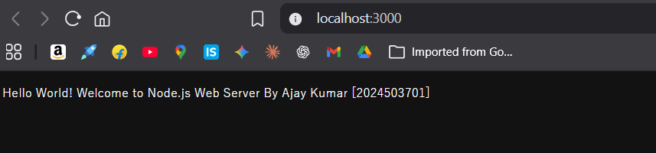
Figure(d)localhost

Result:
Thus, the web server and XML data handling system have been implemented successfully, and the output was generated by reading and parsing the XML file, displaying the student information on the console.

